Extra Practice 6

|  |
| --- |
| Lección 7.6: Arboles De Probabilidad  Master 7.24   1. Un tetrahedron regular tiene caras 1 al 4. Un dado tiene caras 1 al 6.  Supón que primero lanzas el tetrahedron, y luego lanzas el dado.   **a)** Haz un árbol de probabilidad y señala todos los “outcomes” posibles  **b)** Encuentra la probabilidad de cada uno de los siguientes eventos:  **i)** De que salgan dos números pares  **ii)** De que salgan dos números cuya suma es 6  **iii)** De que salga un 4  **iv)** De que salgan dos números cuya restaes 0 o 1.     1. TG8_11_M11Este juego se llama *Sum Up.* 2. Enumera todas las sumas posibles entre los   números de las dos ruedas.   1. Haz un árbol de probabilidad con todos los   resultados *(“outcomes”)* posibles.    **c)** ¿Cuál es la probabilidad teórica de obtener cada suma que enumeraste en la parte a? |

Extra Practice 6 – Master 7.24

**1. a)** Answers may vary.I made orange 6 times in 20 trials.

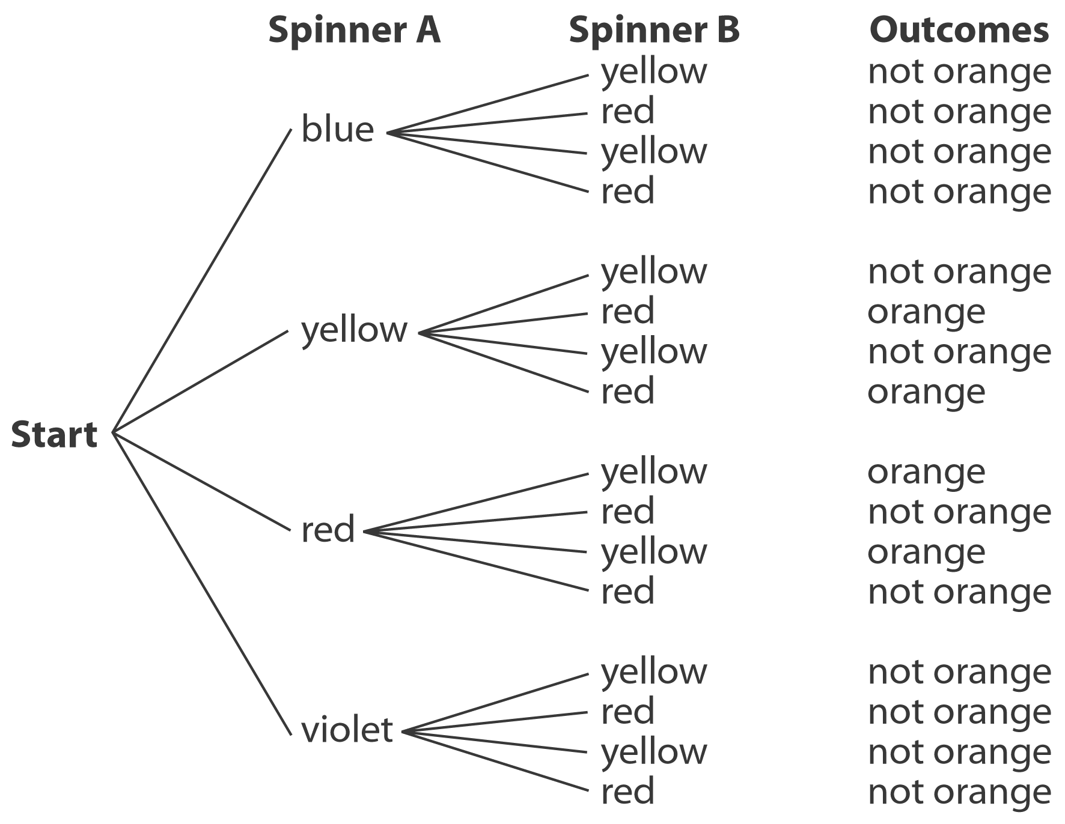 **b)** Answers may vary. *Sample answer:* In 200 trials, orange was made 47 times. The experimental probability of making orange is , or about 24%.

**c)**

**d)** There are 16 possible outcomes. There are 4 outcomes that make orange.   
The probability of making orange is  or 25%.

**e)** Answers may vary. The experimental probability of making orange is about 24% and the theoretical probability is 25%. They are very close in value.

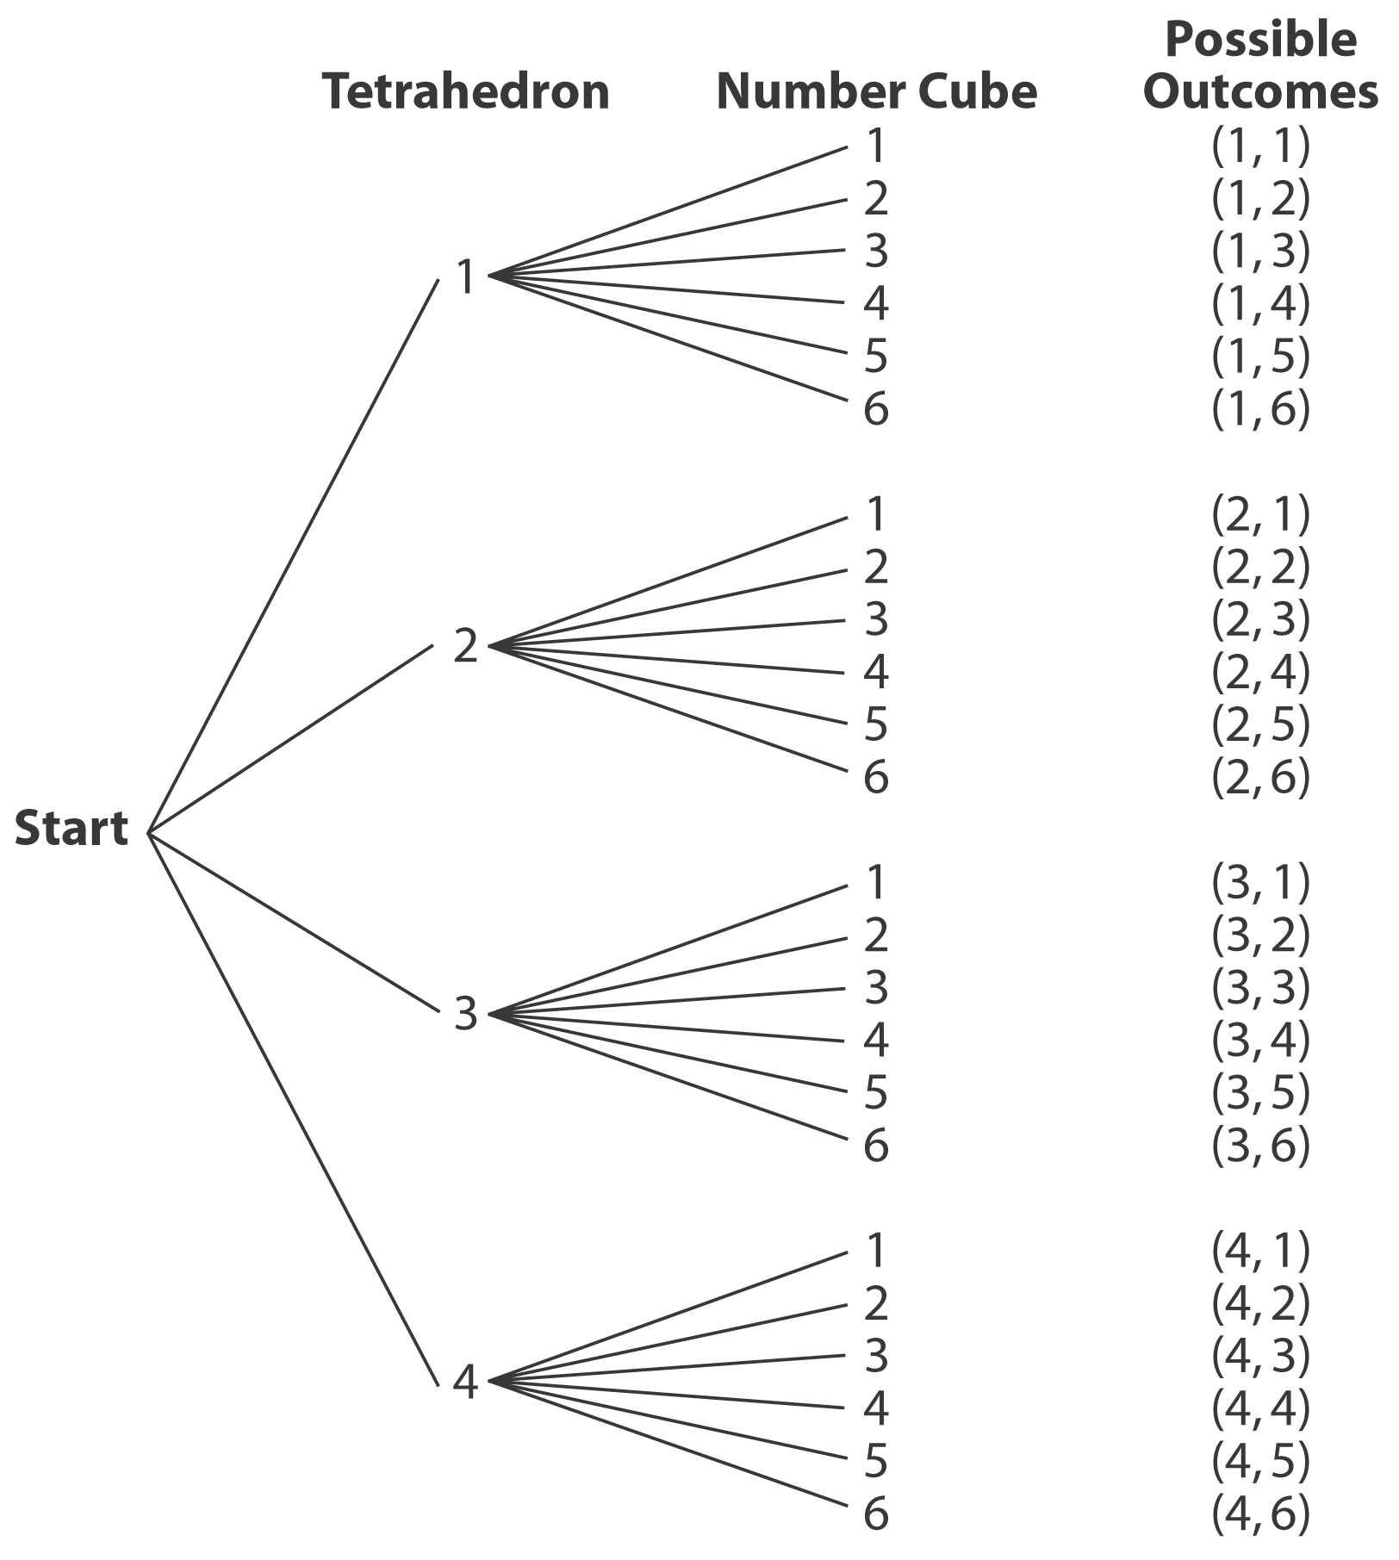**2. a)**

**b)** There are 24 possible outcomes.

**i)** There are 6 outcomes with two even numbers:   
(2, 2), (2, 4), (2, 6), (4, 2), (4, 4), and (4, 6).   
The probability of rolling two even numbers is  or 25%.

**ii)** There are 4 outcomes with numbers whose sum is 6: (1, 5), (2, 4), (3, 3), and (4, 2).   
The probability of rolling two numbers whose sum is 2 is  or about 17%.

**iii)** There are 9 outcomes with a 4: (1, 4), (2, 4),   
(3, 4), (4, 1), (4, 2), (4, 3), (4, 4), (4, 5), and   
(4, 6). The probability of rolling a 4 is  or about 38%.

**iv)** There are 11 outcomes with numbers whose difference is 0 or 1: (1, 1), (1, 2), (2, 1), (2, 2),   
(2, 3), ( 3, 2), (3, 3), (3, 4), (4, 3), (4, 4), and (4, 5).  
The probability of rolling numbers whose difference is 0 or 1 is  or about 46%.

**3. a)** The possible sums are: 4, 5, 6, 7, 8, 9

**b)** Answers may vary.

|  |  |  |  |  |  |  |
| --- | --- | --- | --- | --- | --- | --- |
| Sum | 4 | 5 | 6 | 7 | 8 | 9 |
| Frequency | 2 | 2 | 5 | 7 | 4 | 0 |

**c)** Answers may vary.

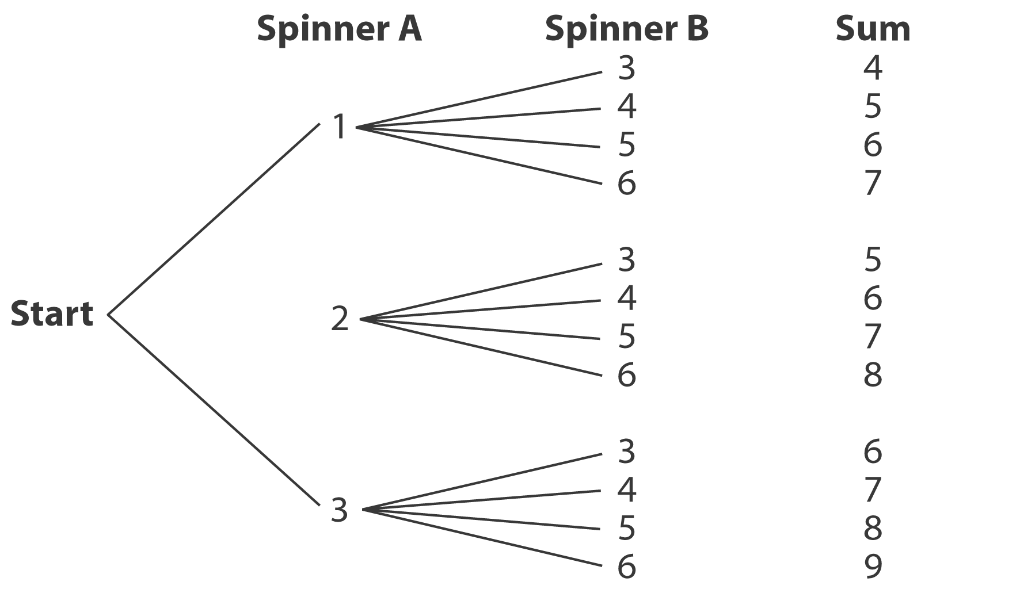 **d)**

**e)** There are 12 possible outcomes.

**i)** There is one outcome with sum 9:  or about 8%.

**ii)** There are 5 outcomes with a sum of 6 or 8:  or about 42%.

**iii)** There are 2 outcomes with sum 5:  or about 17%.

**f)** Answers may vary. The values of the experimental probabilities are close to those of the theoretical probabilities. The theoretical and experimental probabilities will become closer in value if the experiment is repeated 1000 times.